# Archival UI Team – Use Cases Draft 2

For Archival User Interface, we came up with three use cases diagrams for now. The first use case diagram shows the overall functions performed by the user. Second use case diagram shows a detailed view of upload functionality, third use case diagram shows a detailed view of retrieval functionality.

**Use case 1- Basic Functionality of the UI:**

The user will be able to upload the files, retrieve the files and perform fixity check on the retrieved files and add steps/comments for resolved errors.

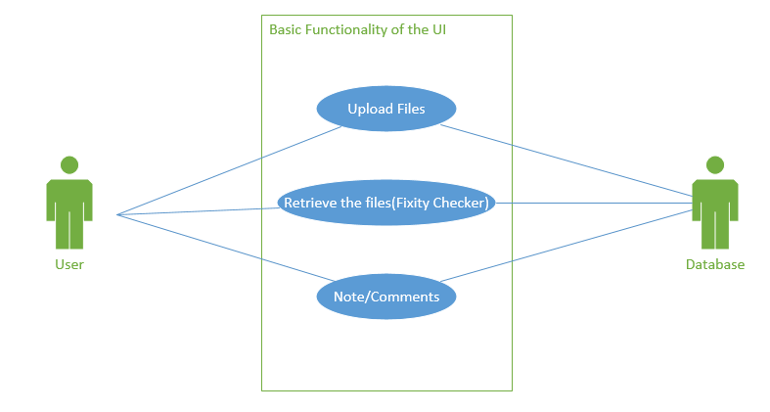

**Use case 2 – Upload Files:**

The user will be able to get the files from an external HDD to the local machine and checks for redundant/duplicate files. And then arranges the files in appropriate folders and finally will upload those files to the archives.

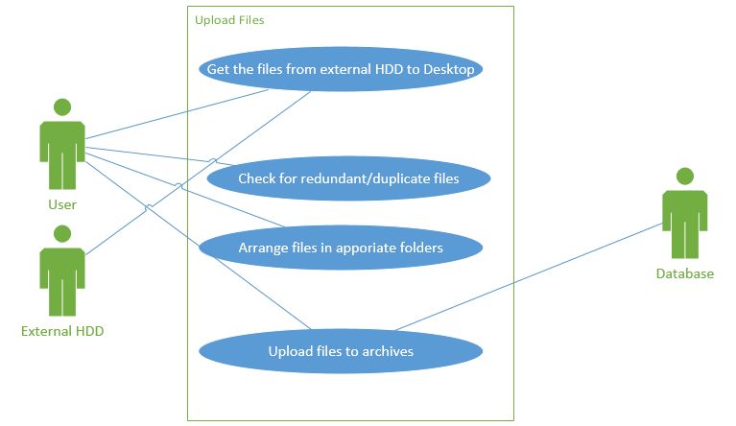

**Use case 3 – Retrieve Files:**

The user retrieves the files from archives and performs fixity check on those retrieved files. Based on the fixity report, user resolves errors and comments are added accordingly.

